Generating various patterns of LED using Aurdino UNO

Circuit Diagram:

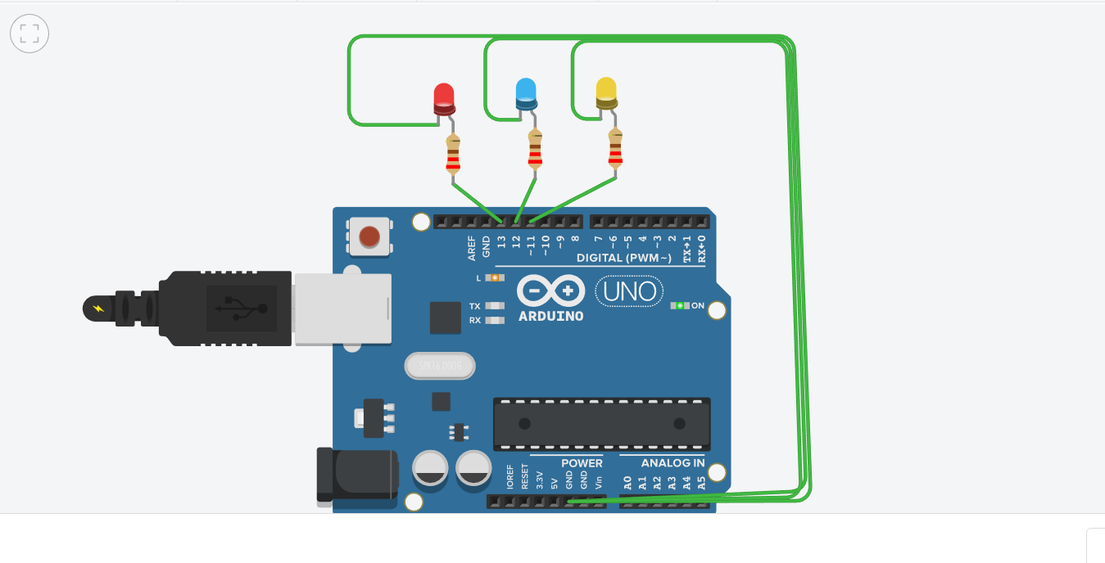

Components requirement:

Aurdino code for this circuit:

// C++ code

//

void setup()

{

pinMode(13, OUTPUT);

pinMode(12, OUTPUT);

pinMode(11, OUTPUT);

}

void loop()

{

digitalWrite(13, HIGH);

digitalWrite(12, HIGH);

digitalWrite(11, HIGH);

delay(1000); // Wait for 1000 millisecond(s)

digitalWrite(13, LOW);

digitalWrite(12, LOW);

digitalWrite(11, LOW);

delay(1000); // Wait for 1000 millisecond(s)

}